Appendix b

PERSONAL LEAVE OF ABSENCE FORM/LEAVE OF ABSENCE

This form should be used to request personal leave of absence from the Academy regardless of the need for cover.
Please discuss and then email the form to you​ line manager and Principal at least one week’s notice to be given
Date of Application:
Employee Name:
Dates of absence:
Number of days/Hours absent from BGA:
Reason for requested absence: (Please provide evidence)
Cover required:
Line Manager’s Signature: | 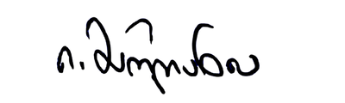
Principal’s Signature:

To be filled in by Human Resources
❏ Paid leave of absence agreed ❏ Unpaid leave of absence agreed
❏ Leave of absence declined
HR Signature:

Date:

